==================================================

Running Genetic Algorithm with LightGBM...

==================================================

==================================================

=== GENETIC ALGORITHM OPTIMIZATION ===

==================================================

[Initialization]

- Population size: 30

- Generations: 20

- Crossover rate: 80%

- Mutation rate: 20%

- Search space: 176 features

- Target: Minimize MSE using LightGBM

==================================================

=== OPTIMIZATION RESULTS ===

==================================================

▶ Best MSE achieved: 10012.983612

▶ Time elapsed: 252.97 seconds

▶ Features selected: 88/176 (50.0% reduction)

▶ Selected features:

1. District

2. Neighborhood

3. m² (Gross)

4. m² (Net)

5. Number of rooms

6. Building Age

7. Floor location

8. Number of floors

9. Heating

10. Number of bathrooms

11. Balcony

12. Using status

13. Available for Loan

14. Swap

15. Front East

16. Front South

17. Front North

18. Smart House

19. Alaturka Toilet

20. Aluminum joinery

21. American kitchen

22. Built-in on

23. Elevator

24. Balcony.1

25. Barbecue

26. Household appliances

27. Shower

28. Parents' Bathroom

29. Insulating glass

30. Cellar

31. Air conditioning

32. Marley

33. Furniture

34. Parquet Floor

35. Set Top Cooker

36. Spot Lighting

37. Terrace

38. Cloakroom

39. Wi-Fi

40. Face Recognition & Fingerprint

41. Laundry room

42. Elevator.1

43. Steam room

44. Security

45. Bath

46. Booster

47. Thermal Insulation

48. Closed Garage

49. Doorman

50. With Private Pool

51. Sauna

52. Sound insulation

53. Sports Area

54. Swimming Pool (Open)

55. Parking Lot

56. Wide Corridor

57. Entrance / Ramp

58. Stairs

59. Socket / Electric Switch

60. Handle / Railing

61. municipality

62. Next to sea shore

63. Synagogue

64. Park.1

65. Gym

66. Unirsity

67. Primary School-Secondary School

68. Town center

69. Bosphorus Bridges

70. Street

71. Sea bus

72. Airport

73. Metro

74. Bus stop

75. Coast

76. TEM

77. Cable car

78. Railway station

79. Throat

80. Sea

81. Nature

82. Pool

83. Garden Floor

84. Garden

85. Top floor

86. Triplex

87. Ground floor

88. Roof Duplex

▶ Convergence progress:

- Initial MSE: 10381.2519

- Final MSE: 10012.9836

- Improvement: 3.5%

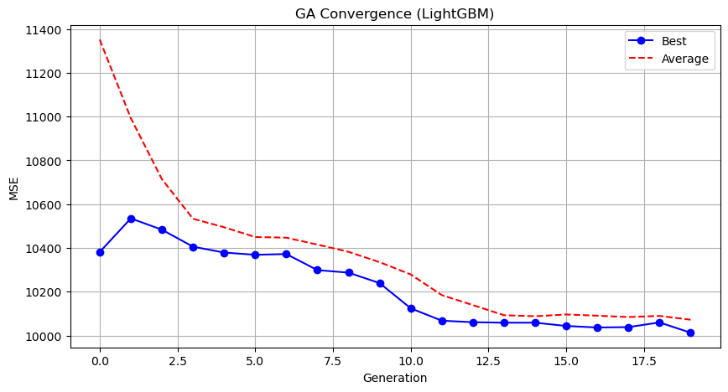

Genetic Algorithm completed successfully with MSE: 10012.9836

==================================================

Running Particle Swarm Optimization with LightGBM...

==================================================

==================================================

=== PARTICLE SWARM OPTIMIZATION ===

==================================================

[Initialization]

- Swarm size: 30 particles

- Iterations: 20

- Cognitive weight: 0.5

- Social weight: 0.5

- Inertia weight: 0.5

- Search space: 176 features

- Target: Minimize MSE using LightGBM

Stopping search: maximum iterations reached --> 20

==================================================

=== OPTIMIZATION RESULTS ===

==================================================

▶ Best MSE achieved: 10203.975027

▶ Time elapsed: 269.31 seconds

▶ Features selected: 95/176 (46.0% reduction)

▶ Selected features (with weights):

1. District (weight: 0.803)

2. Neighborhood (weight: 0.874)

3. m² (Gross) (weight: 0.758)

4. m² (Net) (weight: 0.721)

5. Number of rooms (weight: 0.510)

6. Building Age (weight: 0.635)

7. Floor location (weight: 0.624)

8. Number of floors (weight: 0.603)

9. Number of bathrooms (weight: 0.752)

10. Balcony (weight: 0.854)

11. Furnished (weight: 0.623)

12. Using status (weight: 0.707)

13. Available for Loan (weight: 0.567)

14. From who (weight: 0.518)

15. Front East (weight: 1.000)

16. Front South (weight: 0.719)

17. Front North (weight: 0.968)

18. ADSL (weight: 0.809)

19. Smart House (weight: 0.921)

20. Alarm (Thief) (weight: 0.542)

21. Alarm (Fire) (weight: 0.560)

22. Aluminum joinery (weight: 0.627)

23. American Door (weight: 0.862)

24. American kitchen (weight: 0.629)

25. Barbecue (weight: 0.936)

26. Painted (weight: 0.744)

27. Parents' Bathroom (weight: 0.960)

28. Dressing room (weight: 1.000)

29. Intercom System (weight: 0.840)

30. Plasterboard (weight: 0.568)

31. Laminate Floor (weight: 0.555)

32. Marley (weight: 0.957)

33. Furniture (weight: 0.875)

34. Kitchen (Laminate) (weight: 0.641)

35. PVC Joinery (weight: 0.898)

36. Blinds (weight: 0.876)

37. Spot Lighting (weight: 0.601)

38. Cloakroom (weight: 0.694)

39. Wi-Fi (weight: 0.767)

40. Face Recognition & Fingerprint (weight: 0.575)

41. Washing machine (weight: 0.845)

42. Steel door (weight: 0.612)

43. Water heater (weight: 1.000)

44. Fireplace (weight: 0.635)

45. Security (weight: 0.849)

46. Bath (weight: 0.867)

47. Booster (weight: 0.576)

48. Thermal Insulation (weight: 0.757)

49. Generator (weight: 0.839)

50. Closed Garage (weight: 0.688)

51. Doorman (weight: 0.740)

52. Nursery (weight: 0.599)

53. Playground (weight: 0.769)

54. Sauna (weight: 0.944)

55. Sound insulation (weight: 0.882)

56. Siding (weight: 0.633)

57. Sports Area (weight: 0.675)

58. Water tank (weight: 0.769)

59. Satellite (weight: 0.546)

60. Swimming Pool (Indoor) (weight: 0.546)

61. Parking Lot (weight: 0.886)

62. Wide Corridor (weight: 0.706)

63. Entrance / Ramp (weight: 0.514)

64. Socket / Electric Switch (weight: 0.774)

65. Toilet (weight: 0.658)

66. Swimming pool (weight: 0.639)

67. The mall (weight: 0.574)

68. Mosque (weight: 0.592)

69. Pharmacy (weight: 0.686)

70. Amusement center (weight: 0.900)

71. Synagogue (weight: 0.725)

72. The church (weight: 0.702)

73. Market (weight: 0.638)

74. Police station (weight: 0.634)

75. District Market (weight: 0.963)

76. Gym (weight: 0.649)

77. Unirsity (weight: 0.718)

78. Highway (weight: 0.637)

79. Street (weight: 0.605)

80. Sea bus (weight: 0.522)

81. E-5 (weight: 0.520)

82. Airport (weight: 0.707)

83. Marmaray (weight: 0.586)

84. Metro (weight: 0.782)

85. Bus stop (weight: 0.679)

86. Tram (weight: 0.909)

87. Railway station (weight: 0.720)

88. Sea (weight: 0.678)

89. Nature (weight: 0.587)

90. Garden Floor (weight: 0.817)

91. Garden (weight: 0.555)

92. Top floor (weight: 0.681)

93. Entrance floor (weight: 0.516)

94. Floor Duplex (weight: 0.711)

95. Triplex (weight: 0.609)

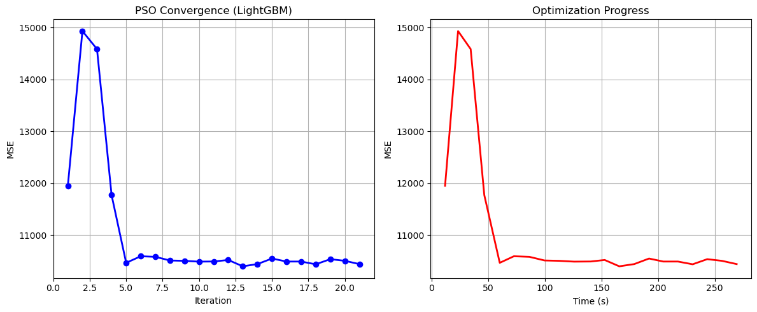

Particle Swarm Optimization completed successfully with MSE: 10203.9750

==================================================

Running Whale Optimization with LightGBM...

==================================================

==================================================

=== WHALE OPTIMIZATION ALGORITHM ===

==================================================

[Initialization]

- Population: 30 whales

- Max iterations: 20

- Spiral coefficient (b): 1.0

- Search space: 176 features

- Target: Minimize MSE using LightGBM

==================================================

=== OPTIMIZATION RESULTS ===

==================================================

▶ Best MSE achieved: 10135.403664

▶ Time elapsed: 260.52 seconds

▶ Features selected: 128/176 (27.3% reduction)

▶ Selected features:

1. District

2. Neighborhood

3. m² (Gross)

4. m² (Net)

5. Number of rooms

6. Building Age

7. Floor location

8. Number of floors

9. Heating

10. Number of bathrooms

11. Furnished

12. Using status

13. Available for Loan

14. From who

15. Swap

16. Front West

17. Front East

18. Front South

19. Front North

20. Wood Joinery

21. Smart House

22. Alarm (Thief)

23. Aluminum joinery

24. Built-in on

25. Elevator

26. Balcony.1

27. Dishwasher

28. Refrigerator

29. Parents' Bathroom

30. Fiber Internet

31. On

32. Dressing room

33. Intercom System

34. Insulating glass

35. Plasterboard

36. Cellar

37. Air conditioning

38. Tub

39. Marley

40. Furniture

41. Kitchen (Built-in)

42. Kitchen (Laminate)

43. Kitchen Natural Gas

44. Blinds

45. Ceramic Floor

46. Set Top Cooker

47. Terrace

48. Wi-Fi

49. Face Recognition & Fingerprint

50. Washing Machine

51. Washing machine

52. Laundry room

53. Fireplace

54. Bath

55. Booster

56. Generator

57. Closed Garage

58. Doorman

59. With Private Pool

60. Car park

61. Playground

62. Sauna

63. Sound insulation

64. Sports Area

65. Water tank

66. Tennis court

67. Satellite

68. Fire escape

69. Swimming Pool (Open)

70. Swimming Pool (Indoor)

71. Elevator.2

72. Bathroom

73. Wide Corridor

74. Entrance / Ramp

75. Stairs

76. Kitchen

77. Room door

78. Socket / Electric Switch

79. Handle / Railing

80. Toilet

81. Cemevi

82. Next to sea shore

83. Amusement center

84. Fair

85. Hospital

86. Synagogue

87. The church

88. High school

89. Market

90. The health clinic

91. District Market

92. Gym

93. Unirsity

94. Primary School-Secondary School

95. Fire Department

96. Town center

97. Highway

98. Eurasia Tunnel

99. Bosphorus Bridges

100. Street

101. Sea bus

102. Filled

103. Airport

104. Marmaray

105. Metro

106. Metrobus

107. Bus stop

108. Coast

109. TEM

110. Cable car

111. Railway station

112. Trolley bus

113. Scaffolding

114. Throat

115. Sea

116. Nature

117. Lake

118. Park & ​​Green Area

119. City

120. Mezzanine Duplex

121. Garden Duplex

122. Garden Floor

123. Garden

124. Top floor

125. Entrance floor

126. Private Entry

127. Rerse Duplex

128. Roof Duplex

▶ Convergence progress:

- Initial MSE: 14168.2535

- Final MSE: 10203.9527

- Improvement: 28.0%

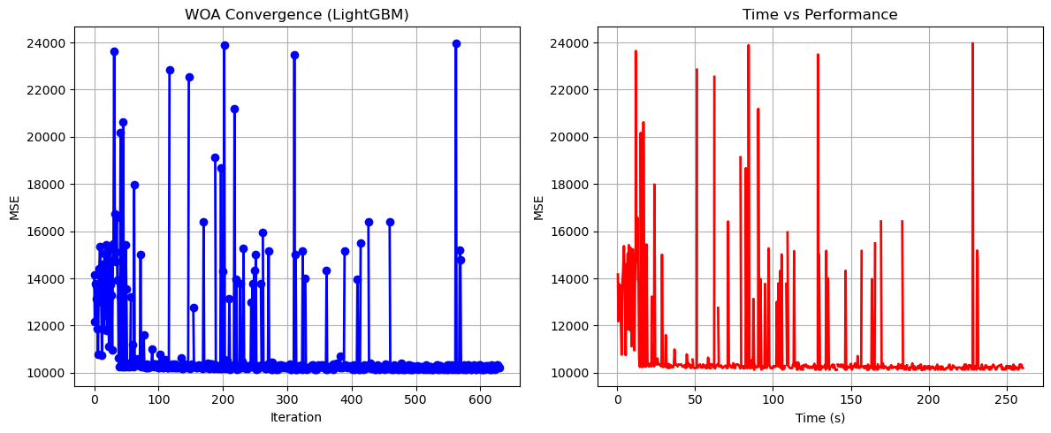

Whale Optimization completed successfully with MSE: 10135.4037

==================================================

Running Squid Game Optimizer with LightGBM...

==================================================

==================================================

=== SQUID GAME OPTIMIZER (SGO) ===

==================================================

[Initialization]

- Players: 30 (15 offensive, 15 defensive)

- Max games: 20

- Search space: 176 features

- Target: Minimize MSE using LightGBM

==================================================

=== OPTIMIZATION RESULTS ===

==================================================

▶ Best MSE achieved: 10128.517541

▶ Time elapsed: 229.11 seconds

▶ Features selected: 62/176 (64.8% reduction)

▶ Selected features:

1. District

2. Neighborhood

3. m² (Gross)

4. Building Age

5. Floor location

6. Number of floors

7. Heating

8. Number of bathrooms

9. Available for Loan

10. From who

11. Front West

12. ADSL

13. Alarm (Thief)

14. Alarm (Fire)

15. American kitchen

16. Built-in on

17. Barbecue

18. Fiber Internet

19. Jacuzzi

20. Laminate Floor

21. Kitchen (Laminate)

22. Ceramic Floor

23. Terrace

24. Washing machine

25. Steel door

26. Water heater

27. Elevator.1

28. Security

29. Cable TV

30. Closed Garage

31. Nursery

32. Sauna

33. Siding

34. Tennis court

35. Swimming Pool (Open)

36. Elevator.2

37. Stairs

38. Kitchen

39. The mall

40. Mosque

41. Next to sea shore

42. Fair

43. Market

44. The health clinic

45. District Market

46. Gym

47. Unirsity

48. Town center

49. Highway

50. Street

51. Filled

52. Airport

53. Marmaray

54. Railway station

55. Sea

56. Nature

57. Mezzanine

58. Mezzanine Duplex

59. Top floor

60. Garage / Shop Top

61. Private Entry

62. Ground floor

▶ Convergence progress:

- Initial MSE: 10314.9674

- Final MSE: 10128.5175

- Improvement: 1.8%

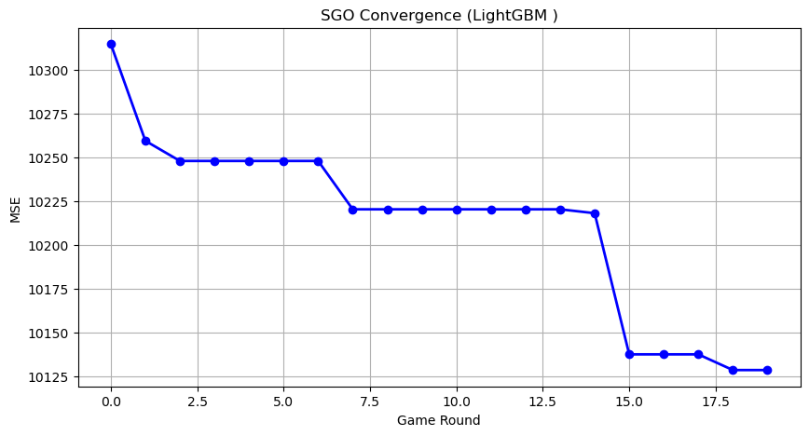

Squid Game Optimizer completed successfully with MSE: 10128.5175

==================================================

Running PSH-Hyptrite with LightGBM...

==================================================

==================================================

=== PSH-HYPTRITE OPTIMIZATION ===

==================================================

[Initialization]

- Search points: 30

- Max iterations: 20

- Initial radius: 0.5 (adaptive)

- Hypersphere samples: 3 per point

- Search space: 176 features

- Target: Minimize MSE using LightGBM

==================================================

=== OPTIMIZATION RESULTS ===

==================================================

▶ Best MSE achieved: 10283.038415

▶ Time elapsed: 751.64 seconds

▶ Features selected: 99/176 (43.8% reduction)

▶ Selected features (with weights):

1. District (weight: 0.884)

2. Neighborhood (weight: 0.894)

3. m² (Gross) (weight: 0.785)

4. Number of rooms (weight: 0.550)

5. Building Age (weight: 0.615)

6. Floor location (weight: 0.602)

7. Heating (weight: 0.936)

8. Number of bathrooms (weight: 0.763)

9. Furnished (weight: 0.544)

10. Using status (weight: 0.813)

11. Available for Loan (weight: 0.699)

12. Swap (weight: 0.651)

13. Front East (weight: 0.654)

14. Front South (weight: 0.729)

15. Front North (weight: 0.768)

16. ADSL (weight: 0.634)

17. Wood Joinery (weight: 0.628)

18. Smart House (weight: 0.578)

19. Alaturka Toilet (weight: 0.516)

20. Aluminum joinery (weight: 0.912)

21. American Door (weight: 0.631)

22. American kitchen (weight: 0.781)

23. Balcony.1 (weight: 0.817)

24. Household appliances (weight: 0.900)

25. Painted (weight: 0.832)

26. Dishwasher (weight: 0.731)

27. Refrigerator (weight: 0.611)

28. Wall paper (weight: 0.695)

29. Shower (weight: 0.710)

30. Parents' Bathroom (weight: 0.680)

31. On (weight: 0.694)

32. Dressing room (weight: 0.687)

33. Closet (weight: 0.619)

34. Intercom System (weight: 0.838)

35. Insulating glass (weight: 0.942)

36. Air conditioning (weight: 0.501)

37. Tub (weight: 0.980)

38. Laminate Floor (weight: 0.541)

39. Marley (weight: 1.000)

40. Kitchen (Built-in) (weight: 0.532)

41. Kitchen (Laminate) (weight: 0.697)

42. Kitchen Natural Gas (weight: 0.909)

43. Parquet Floor (weight: 0.836)

44. Ceramic Floor (weight: 0.985)

45. Spot Lighting (weight: 0.927)

46. Thermosiphon (weight: 0.799)

47. Cloakroom (weight: 0.888)

48. Washing Machine (weight: 0.832)

49. Washing machine (weight: 0.527)

50. Laundry room (weight: 0.985)

51. Water heater (weight: 0.798)

52. Fireplace (weight: 0.509)

53. Bath (weight: 0.773)

54. Thermal Insulation (weight: 0.882)

55. Generator (weight: 0.509)

56. Doorman (weight: 0.640)

57. With Private Pool (weight: 0.553)

58. Car park (weight: 0.545)

59. Playground (weight: 0.624)

60. Tennis court (weight: 0.881)

61. Swimming Pool (Indoor) (weight: 0.957)

62. Parking Lot (weight: 0.531)

63. Elevator.2 (weight: 0.600)

64. Entrance / Ramp (weight: 0.695)

65. Park (weight: 0.927)

66. Toilet (weight: 0.834)

67. Swimming pool (weight: 0.651)

68. The mall (weight: 0.538)

69. Amusement center (weight: 0.861)

70. Hospital (weight: 0.809)

71. Synagogue (weight: 0.852)

72. The church (weight: 0.598)

73. High school (weight: 0.914)

74. Park.1 (weight: 0.994)

75. Police station (weight: 0.724)

76. Unirsity (weight: 0.648)

77. Primary School-Secondary School (weight: 0.994)

78. Eurasia Tunnel (weight: 0.574)

79. Bosphorus Bridges (weight: 0.915)

80. E-5 (weight: 0.660)

81. Airport (weight: 0.597)

82. Marmaray (weight: 0.737)

83. Metro (weight: 1.000)

84. Minibus (weight: 0.855)

85. Cable car (weight: 0.660)

86. Tram (weight: 0.701)

87. Trolley bus (weight: 0.750)

88. Throat (weight: 0.968)

89. Sea (weight: 0.654)

90. Nature (weight: 0.855)

91. Lake (weight: 0.696)

92. City (weight: 0.946)

93. Mezzanine Duplex (weight: 0.906)

94. Garden Duplex (weight: 0.800)

95. Garden (weight: 0.708)

96. Top floor (weight: 1.000)

97. Rerse Duplex (weight: 0.601)

98. Triplex (weight: 0.543)

99. Roof Duplex (weight: 0.933)

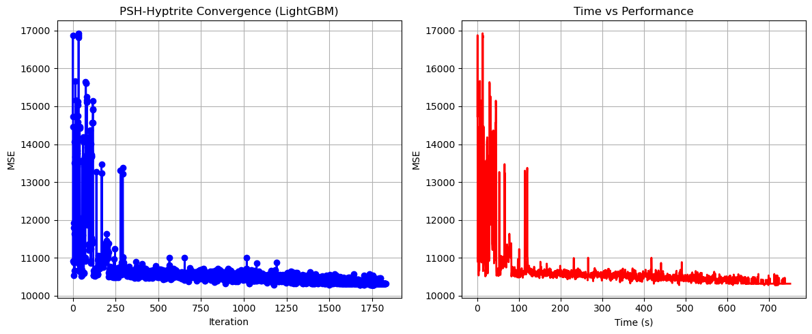

PSH-Hyptrite completed successfully with MSE: 10283.0384

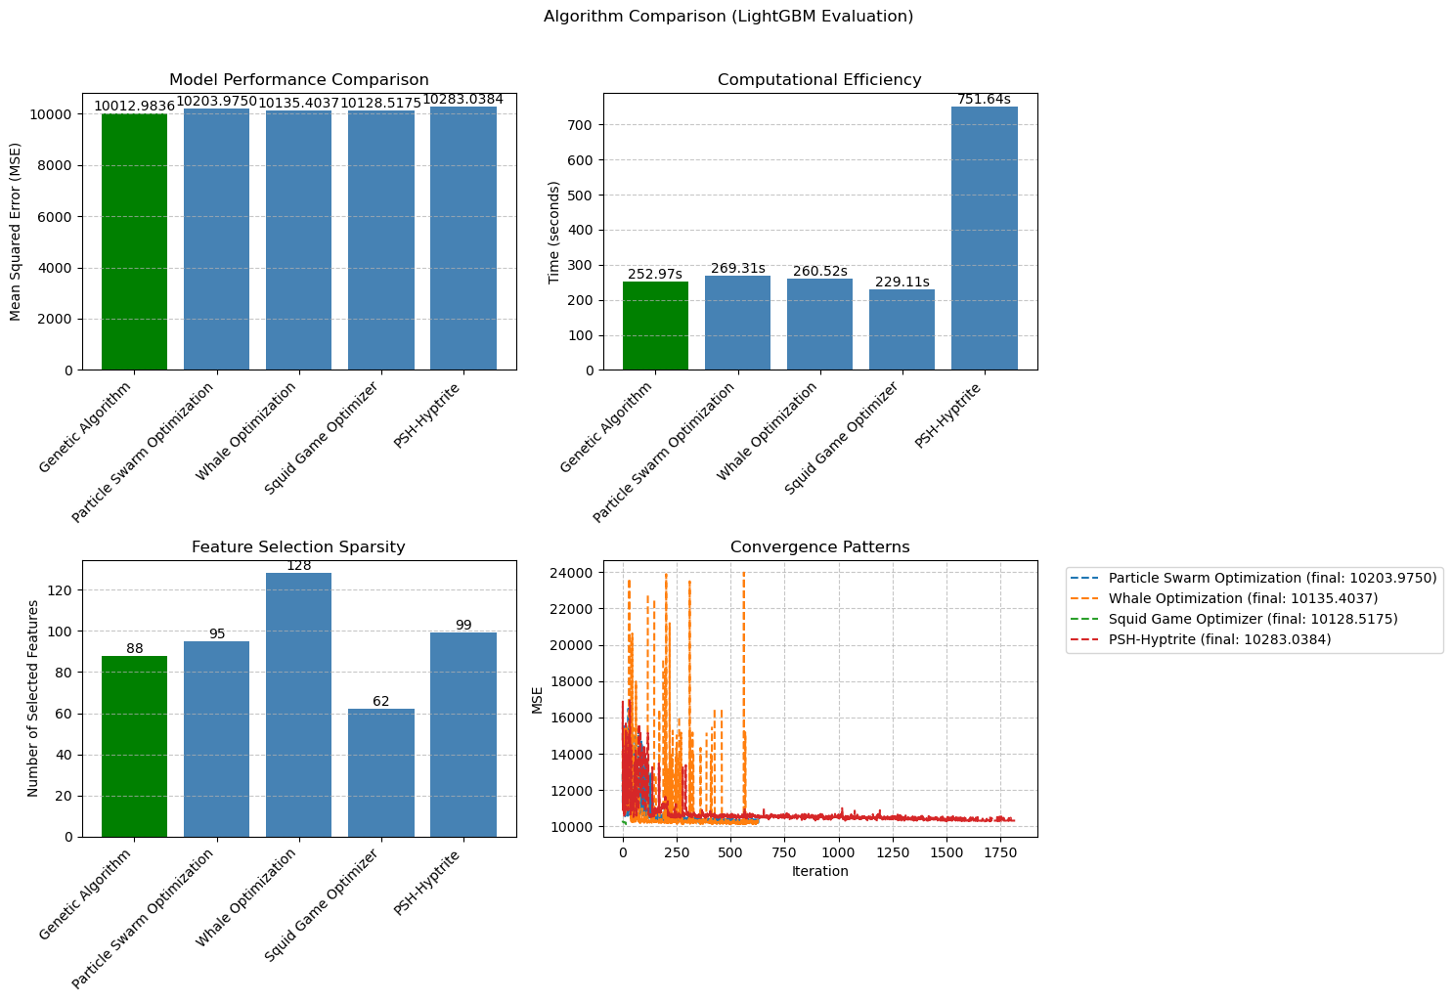

============================================================

=== FINAL FEATURE SELECTION RESULTS USING LightGBM ===

============================================================

🏆 BEST ALGORITHM: GENETIC ALGORITHM

• MSE: 10012.983612

• Time: 252.97 seconds

• Features: 88/176 (50.0% reduction)

📊 COMPARISON TABLE:

Algorithm MSE Time (s) Features

---------------------------------------------------------------------------

Genetic Algorithm 10012.983612 252.97 88

Squid Game Optimizer 10128.517541 229.11 62

Whale Optimization 10135.403664 260.52 128

Particle Swarm Optimization 10203.975027 269.31 95

PSH-Hyptrite 10283.038415 751.64 99

🔍 SELECTED FEATURES:

1. District

2. Neighborhood

3. m² (Gross)

4. m² (Net)

5. Number of rooms

6. Building Age

7. Floor location

8. Number of floors

9. Heating

10. Number of bathrooms

11. Balcony

12. Using status

13. Available for Loan

14. Swap

15. Front East

16. Front South

17. Front North

18. Smart House

19. Alaturka Toilet

20. Aluminum joinery

21. American kitchen

22. Built-in on

23. Elevator

24. Balcony.1

25. Barbecue

26. Household appliances

27. Shower

28. Parents' Bathroom

29. Insulating glass

30. Cellar

31. Air conditioning

32. Marley

33. Furniture

34. Parquet Floor

35. Set Top Cooker

36. Spot Lighting

37. Terrace

38. Cloakroom

39. Wi-Fi

40. Face Recognition & Fingerprint

41. Laundry room

42. Elevator.1

43. Steam room

44. Security

45. Bath

46. Booster

47. Thermal Insulation

48. Closed Garage

49. Doorman

50. With Private Pool

51. Sauna

52. Sound insulation

53. Sports Area

54. Swimming Pool (Open)

55. Parking Lot

56. Wide Corridor

57. Entrance / Ramp

58. Stairs

59. Socket / Electric Switch

60. Handle / Railing

61. municipality

62. Next to sea shore

63. Synagogue

64. Park.1

65. Gym

66. Unirsity

67. Primary School-Secondary School

68. Town center

69. Bosphorus Bridges

70. Street

71. Sea bus

72. Airport

73. Metro

74. Bus stop

75. Coast

76. TEM

77. Cable car

78. Railway station

79. Throat

80. Sea

81. Nature

82. Pool

83. Garden Floor

84. Garden

85. Top floor

86. Triplex

87. Ground floor

88. Roof Duplex

💡 Tip: Consider feature importance from LightGBM for further analysis